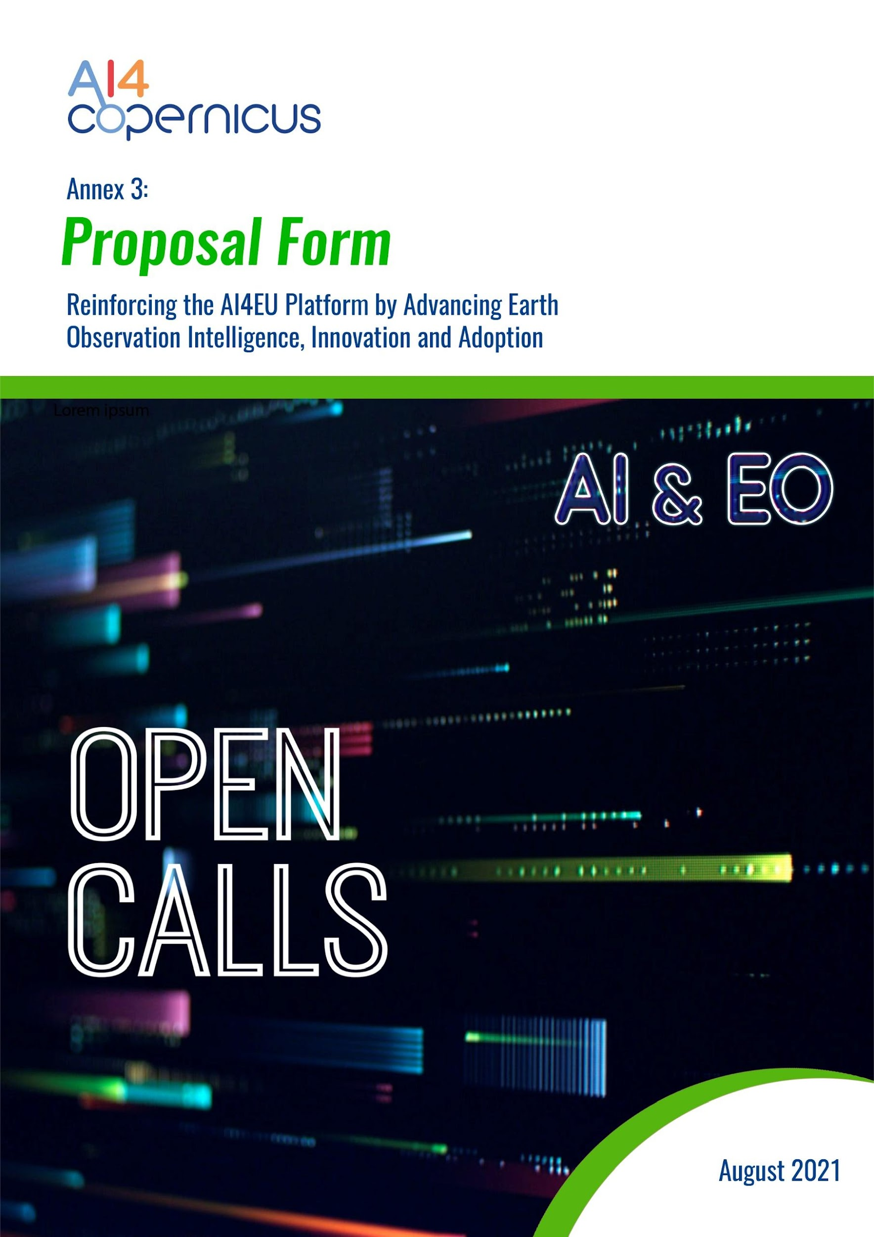

Annex 3: Proposal Template – 2nd Round of Open Calls for Citizen Social Challenges

Table of Contents
Section 1. Excellence [up to 2 pages] 4
1.1. Overview & Ambition [WHY this idea] 4
1.2 Description of the Idea [HOW you envision your idea to work] 4
Section 2. Impact [up to 2 pages] 5
2.1 Expected Social Impacts [WHICH Social Impacts] 5
2.2 Other Expected Impacts [WHICH other Impact Areas] 5

Notes:
- Template Structure: The structure of this template must be followed when preparing your proposal. It has been designed to ensure that the important aspects of your proposed idea, presented in a way that will enable the experts to make an effective assessment against the evaluation criteria. Sections 1 and 2 each correspond to the AI4Copernicus evaluation criteria.
- Εvaluation: Please be aware that proposals will be evaluated as they were submitted, rather than on their potential, if certain changes were to be made. This means that only proposals that successfully address all the required aspects will have a chance of being funded.
- Page limit: Sections 1, & 2, together, should not be longer than 4 pages (Annex 3: Proposal Template). All tables, figures, references and any other element pertaining to these sections must be included as an integral part of these sections and are thus counted against this page limit. The page limit of 4 pages will be applied; therefore you must remove this instruction page (as well as all other highlighted instructions within the template) before submitting. Please note that if your proposal exceeds the page limit of 4 pages (Section 1-2) then after page 4 the content will not be considered during evaluation.
- Format: The reference font for the body text of proposals is Calibri (Windows platforms/Apple platforms). All tables must be included within this limit. The minimum font size allowed is 11 points. The page size is A4, and all margins (top, bottom, left, right) should be at least 15 mm (not including any footers or headers).
Please do not consider the page limit as a target! It is in your interest to keep your text as concise as possible, since experts rarely view unnecessarily long proposals in a positive light
Please eliminate this page when submitting the proposal

Section 1. Excellence [up to 2 pages]

1.1. Overview & Ambition [WHY this idea]
Please describe briefly:
- Challenge: The social challenge(s) that you try to address.
- Target Audience: The target audience and the direct and indirect beneficiaries (i.e., special groups of users/beneficiaries if any, companies that will commercialise the solution, the cities, Europe/other regions, the world, etc.)
- Idea-Ambition-Impact: Your idea, the broader ambition and overall impact. Why should this idea be selected ?

1.2 Description of the Idea [HOW you envision your idea to work]
  - Describe the concept of your idea, its objectives and how you envision your idea to work.
  - Describe how you envision the use of Earth Observation Data in the context of your idea.
  - Describe how you envision the use of Artificial Intelligence (AI) technology in the context of your idea.
  - Please describe in detail how your idea will contribute to/solve the social challenge(s) that you identified.
- Describe any potential risks that can be associated with this idea and its implementation.

Section 2. Impact [up to 2 pages]

2.1 Expected Social Impacts [WHICH Social Impacts]
Please describe the expected social impacts: indicate how your proposed idea/theme might contribute to pave the way to create for example for solve social challenges, solve environmental challenges (environmental impact), the creation of new jobs (economic impact), etc.

Type of Expected Impact(s) (i.e., social, environmental, economic, business, etc) | Description
Social Impact(s)
(Please add another row if needed)

2.2 Other Expected Impacts [WHICH other Impact Areas]
Please describe how the proposed theme/social cause might contribute to other impact areas for example: contribute to the realisation of the United Nations Sustainable Development Goals (SDG) as presented in the 2030 Agenda for Sustainable Development, etc.

Type of Expected Impact(s) | Description
Sustainable Development Goal (SDG) x
(Please add another row if needed)

The 17 SDGs are: (1) No Poverty, (2) Zero Hunger, (3) Good Health and Well-being, (4) Quality Education, (5) Gender Equality, (6) Clean Water and Sanitation, (7) Affordable and Clean Energy, (8) Decent Work and Economic Growth, (9) Industry, Innovation and Infrastructure, (10) Reducing Inequality, (11) Sustainable Cities and Communities, (12) Responsible Consumption and Production, (13) Climate Action, (14) Life Below Water, (15) Life On Land, (16) Peace, Justice, and Strong Institutions, (17) Partnerships for the Goals.

