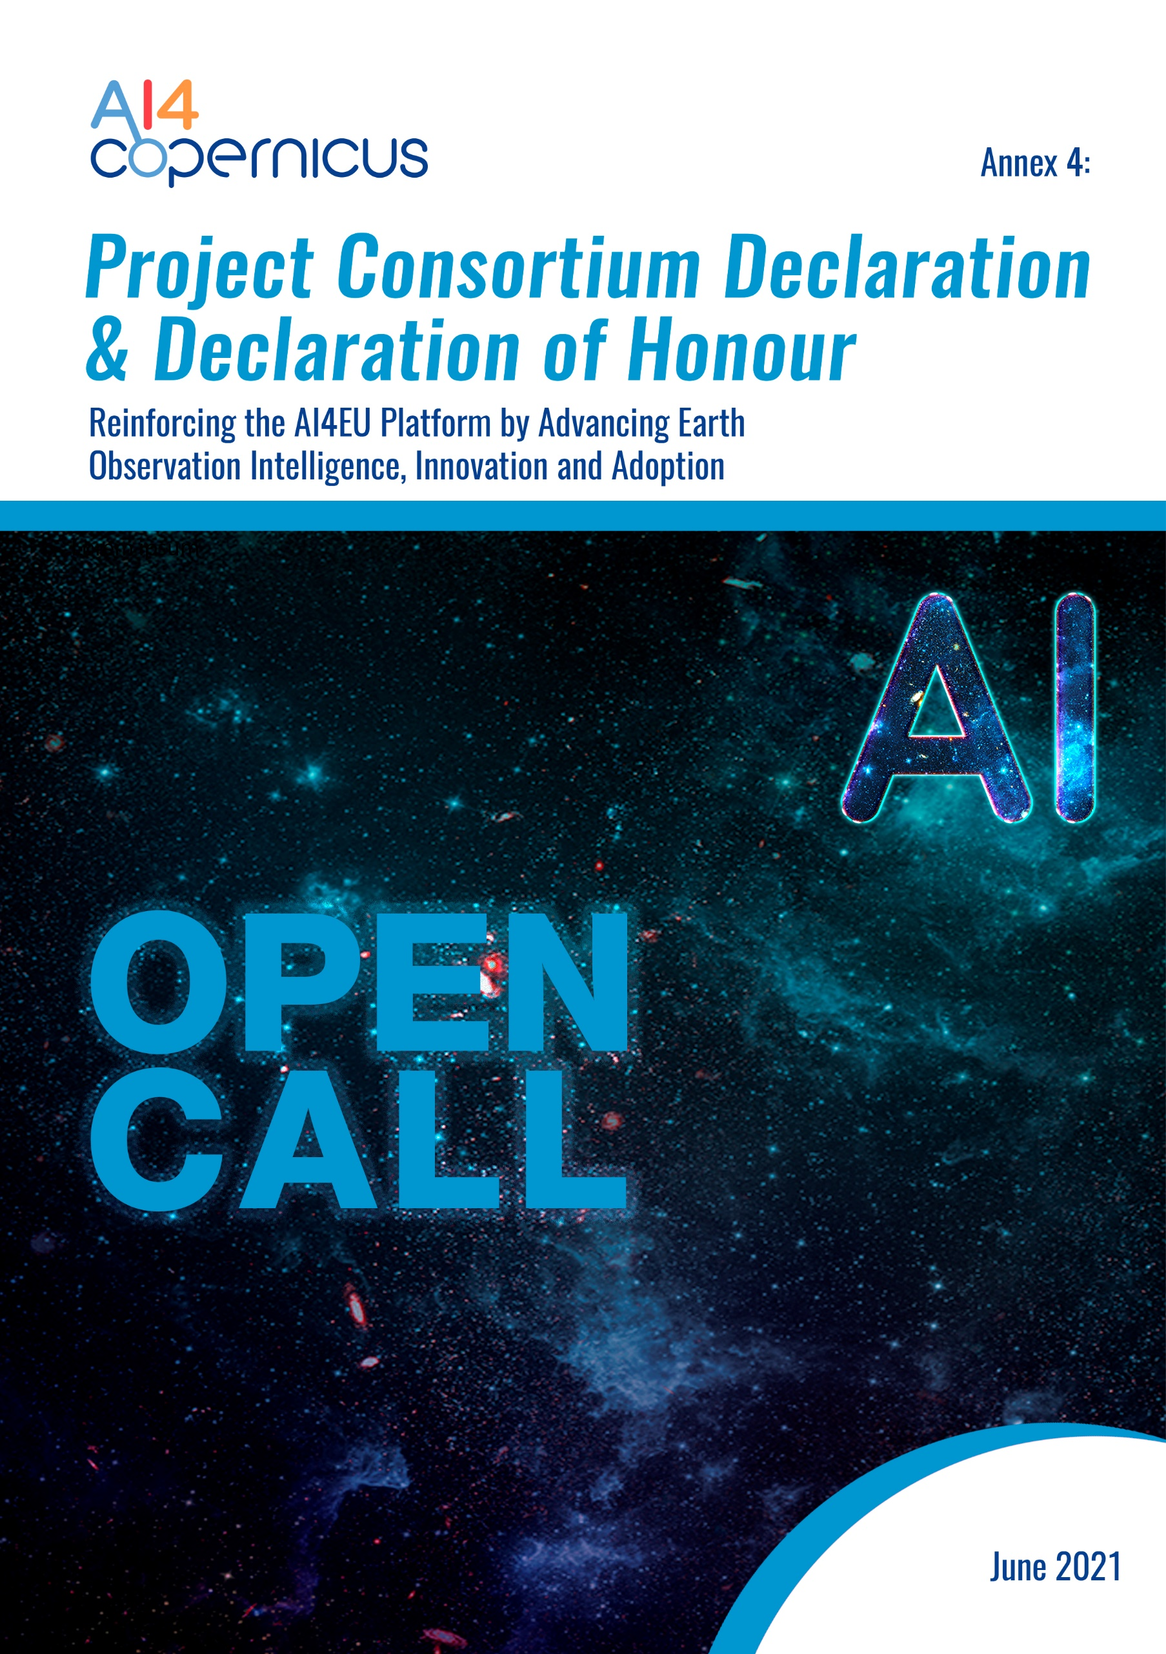

Consortium Declaration

Title of the Project: ________________________________________________________

On behalf of _____________________________(Company name) established in ______________________________, (Official address), VAT/TAX number_________________, represented for the purposes of signing and submitting the Declaration by ___________________________ (Name of legal representative), declares that:
- All provided information below is true and legally binding.
- All Consortium partners represented and signing herein, have agreed on their roles and budget shares.
- All Consortium partners represented and signing herein are eligible in accordance with the criteria set out in the specific call for proposals, have the required financial and operational capacity as set out in [name of the specific call for proposals]
- The Consortium leader is solely responsible to distribute the budget shares to Consortium partners in accordance to this Consortium Declaration.
- AI4Copernicus Consortium bears no responsibility in case the Consortium leader violates the mutual agreement set in this Consortium Declaration.
- ΑΙ4Copernicus Consortium bears no responsibility in case of dispute among consortium partners regarding IP rights.
- To the extent that performance of the Consortium partners under the (Name of the project) requires the processing of personal data as defined in the GDPR, ΑΙ4Copernicus Consortium bears no responsibility in case of any losses, liabilities, damages, costs, charges, claims cost of breach notification including notifications to the data subject, cost of complaints handling (including providing data subjects with credit reference checks, setting up contact centres (e.g. call centres) and making ex gratia payments), all whether arising in contract, tort (including negligence), breach of statutory duty or otherwise imposed.

By signing this declaration, the coordinator of the consortium declares that it is not coordinating any other competitive Consortium in AI4Coperinicus Open Call __. In case, the coordinator of the consortium coordinates more than one Consortia, all associated proposals will be automatically excluded from the evaluation process.
By submitting this document, the Consortium accepts all the rules explained in AI4Copernicus Guidelines for Applicants.

Coordinator Leader Contact Information:

Title (Mr, Mrs, Dr.)
Name
Surname
Job Title
Affiliation
Full Address
Country
Email Address
Telephone
Mobile
Signature and stamp

Declaration of Honour on exclusion criteria and absence of conflict of interest

All participants signing this declaration of honour declare that all provided information below is true and legally binding:

1. Declares that is not in one of the following situations:
- it is bankrupt or being wound up, is having its affairs administered by the courts, has entered into an arrangement with creditors, has suspended business activities, is the subject of proceedings concerning those matters, or is in any analogous situation arising from a similar procedure provided for in national legislation or regulations;
- it or persons having powers of representation, decision making or control over it have been convicted of an offence concerning their professional conduct by a judgment which has the force of res judicata;
- it has been guilty of grave professional misconduct proven by any means which the contracting authority can justify including by decisions of the European Investment Bank and international organizations;
- it is not in compliance with its obligations relating to the payment of social security contributions or the payment of taxes in accordance with the legal provisions of the country in which it is established or with those of the country of the contracting authority or those of the country where the contract is to be performed;
- it or persons having powers of representation, decision making or control over it have been the subject of a judgment which has the force of res judicata for fraud, corruption, involvement in a criminal organization or any other illegal activity, where such illegal activity is detrimental to the Union’s financial interests;
- is subject to an administrative penalty for being guilty of misrepresenting the information required by the contracting authority as a condition of participation in a grant award procedure or another procurement procedure or failing to supply this information or having been declared to be in serious breach of its obligations under contracts or grants covered by the Union's budget.

2. Declares that:
- is not subject to a conflict of interest;
- has not made false declarations in supplying the information required by the as a condition of participation in the Open Calls of AI4Copernicus Project or does not fail to supply this information;
- is not in one of the situations of exclusion, referred to in the above mentioned points a) to f).
- Is aware and fully accepts all AI4Copernicus condition and rules as expressed in AI4Copernicus open call documents Annex 1, Annex 2, Annex 3 and Annex 4.

3. Certifies that:
- is committed to participate in the above mentioned project;
- has stable and sufficient sources of funding to maintain its activity throughout its participation in the above-mentioned project and to provide any counterpart funding necessary;
- has or will have the necessary resources as and when needed to carry out its involvement in the above-mentioned project;

1) Consortium leader (SME/midcap)
Company name
Full address of the company
Country
Name of legal representative
Project Budget share
Legal representative signature and stamp

2) Consortium partner No 2
Organization name
Full address of the organization
Country
Name of legal representative
Project Budget share
Legal representative signature and stamp

3) Consortium partner No 3
Organization name
Full address of the organization
Country
Name of legal representative
Project Budget share
Legal representative signature and stamp

Type of Beneficiary: depending on the type of activity, the beneficiaries can be: - (a) Open Calls for Use-Cases (Domain-Specific, Domain Agnostic) and Experiments: SMEs (individual SMEs and/or consortia of SMEs that are high-technology and/or low or no-tech SMEs) (EU member state or Associated Countries) - (a1) Open Calls for Use-Cases in the domains of Health, Energy, Security, Agriculture (1st Round of Open Calls for Use-Cases): Consortia of SMEs including at least 1 non-or low-tech SME by default - (a2) Open Calls for Use-Cases in any industrial domain based on the citizen-driven social themes/challenges (4th Round of Open Calls for Use-Cases): Consortia of SMEs including at least 1 non-or low-tech SME by default - (a3) Open Calls for Experiments in any industrial domain: - (b) Open Calls for Social Challenges: individuals (18+)

