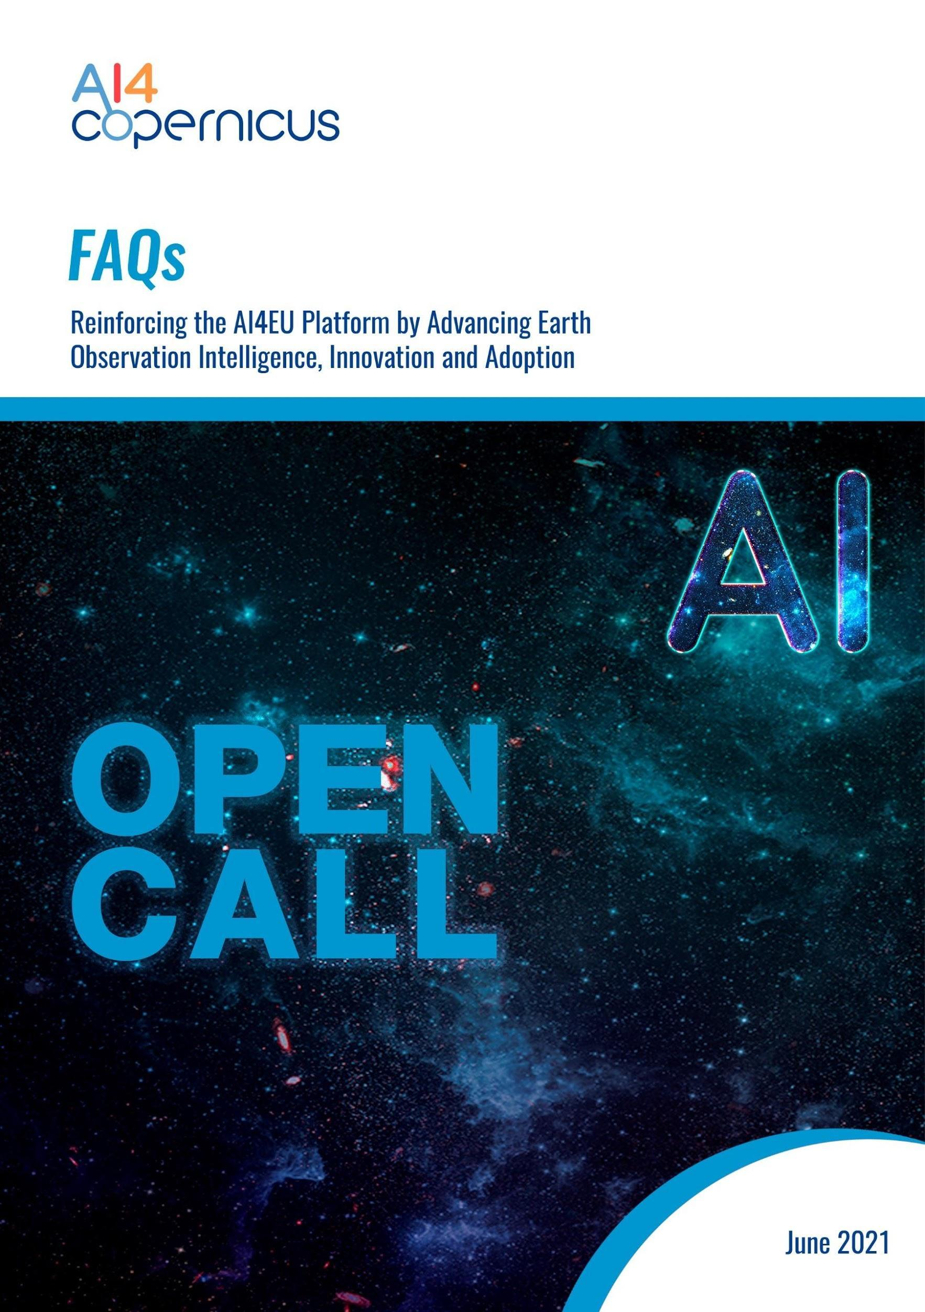

Table of Contents
1. What is AI4Copernicus 2
2. Why should I apply? 2
3. Who can apply? 2
4. Are we considered to be an SME? 2
5. What is considered to be a high-tech and a low-tech SME? 3
6. Any requirements for 1st Round of Open Calls? 3
7. Can AI4Copernicus consortium members apply to this call? 4
8. Can an SME that participated in another AI4EU and/or ICT-49 project, related to Open Call, apply to the AI4Copernicus calls? 4
9. Is it possible to include a non-eligible partner in the consortium as long as it does not obtain any funding? 4
10. What is the difference between a Use-Case and an Experiment? 4
11. What is considered to be a successful proposal? 4
12. What is the funding per project (1st Round of Open Calls)? 4
13. What kind of activities will be supported? 5
14. Can a project cover more than one industrial domain? 6
15. How long does it take to fill in the application? 6
16. Do I have any conflict of interest? 6
17. Will I be able to modify my proposal before final submission? 6
18. Will I be able to modify my proposal after the submission? 6
19. Can my organization submit more than 1 proposal in the same Call? 7
20. I am an individual entrepreneur. Am I eligible for the single-company open calls (3rd Round of Open Call for experiments)? 7
21. I am an individual. Am I eligible for the AI4Copernicus open calls? 7
22. What type of support is available for preparing the proposal? 7
23. Do selected projects get any money in advance? 8
24. What is the payment schedule and payment condition? 8
25. Intellectual Property Rights (IPR) Issues: The IPR stays with whom? 8
26. What will happen to the proposal related data? 8
27. Is there any personal data processing? 8
28. Can I become part of the AI4Copernicus network and community? 9
29. When will the grant agreement be signed? 9

What is AI4Copernicus
ΑI4Copernicus is an EU-funded (H2020) project which aims to enable innovation by bringing together the AI (Artificial Intelligence) and EO (Earth Observation) communities. AI4Copernicus will make the AI4EU AI-on-demand platform the platform of choice for users of Copernicus data along the value chain (scientists, SMEs, non-tech sector), bringing together the knowledge, algorithms, tools and resources available in domains of high economic and societal impact, such as in Agriculture, Energy and Security.

Why should I apply?
Within AI4Copernicus 1st Round of Open Calls, we will identify up to 6 projects regarding Uses-Cases in the fields of Health, Energy, Security and Agriculture that can be implemented by exploiting the existing AI4Copernicus resources and tools.

Who can apply?
Applicants can be consortia of SMEs, startups, that are high-tech and low-tech companies, legally established in:
The Member States of the European Union, or Associated Countries to H2020 (the list of Associated Countries available here).
If you want to participate in the AI4Copernicus Open Call for proposals (Use-cases and/or Experiments), your organisation needs to be registered, have a valid VAT number and have a 9-digit Participant Identification Code (PIC). Please quote your PIC and your partner PIC in the proposal template.
Additional information about the PIC number can be found here.

Are we considered to be an SME?
Small and medium-sized enterprises (SMEs) are defined in the EU recommendation 2003/361. The main factors determining whether an enterprise is an SME are:
(1) staff headcount, (2) either turnover or balance sheet total
Company category | Staff headcount | Turnover | or |  | Balance sheet total
Medium-sized | < 250 | ≤ € 50 m |  | ≤ € 43 m
Small | < 50 | ≤ € 10 m |  | ≤ € 10 m
Micro | < 10 | ≤ € 2 m |  | ≤ € 2 m

These ceilings apply to the figures for individual firms only.
A firm that is part of a larger group may need to include staff headcount/turnover/balance sheet data from that group too.
Additional details can be found: https://ec.europa.eu/growth/smes/sme-definition_en

What is considered to be a high-tech and a low-tech SME?
To date, there is no clear-cut and widely accepted definition for high-tech or low-tech SMEs.
As such AI4Copernicus follows a rather broad conceptual approach without elaborating a very stringent definition or set of indicators.
- High-tech SMEs: are considered to be highly innovative and/or R&D intensive companies and/or use sophisticated and complex technologies such as AI, Internet of Things, Blockchain, Quantum Computing, etc.
- Low-tech or no-tech SMEs: are considered to be companies that do not apply sophisticated technologies such as AI, Internet of Things, Blockchain, Quantum Computing, etc.

Any requirements for 1st Round of Open Calls?
The 1st Round of Open Calls for Use-Cases (consortia projects with a low-technology SME by default) focus on 4 Industrial Domains: Energy, Security, Health, Agriculture will be open from 30 June 2021.

This type of Open Calls involves:
- SME consortia (EU & Associated Countries)
- Include a low-technology/no-technology company by default

Max funding per project:
    - up to € 150.000 (3-partner consortia),
    - up to € 120.000 (2-partner consortia)

Can AI4Copernicus consortium members apply to this call?
Νο, AI4Cppernicus consortium partners cannot be funded by the Call.

Can an SME that participated in another AI4EU and/or ICT-49 project, related to Open Call, apply to the AI4Copernicus calls?
Yes.

Is it possible to include a non-eligible partner in the consortium as long as it does not obtain any funding?
A non-eligible partner could be part of your proposal as a support network partner (with a letter of support) but not as a partner in your consortium.

What is the difference between a Use-Case and an Experiment?
- Use-Cases: small SME consortia projects with at least two members (max 3 partners), including a non-technology advanced partner by default. The end output of Use-Cases should be at min TRL 5.
- Experiments: single beneficiary projects. The end output of the experiments should be at min TRL 6.

What is considered to be a successful proposal?
An innovative proposal that addresses successfully all the AI4Copernicus requirements.

What is the funding per project (1st Round of Open Calls)?
For the 1st Round of Open Calls each selected project will receive up to €150.000 (for max 3 partners) or €120.000 (for 2 partners) .

What kind of activities will be supported?
Developing and testing AI technical solutions that address industrial challenges by exploiting AI resources and Earth Observation Data focusing only on:
4 industrial domains (energy, security, health, agriculture)
The AI4Copernicus support program (acceleration process) involves a 16-month acceleration program, which includes namely
- Phase 3: Support Phase (14 Months) and
- Phase 4: Sustain Phase (2 Months), as can be seen in Figure 1.
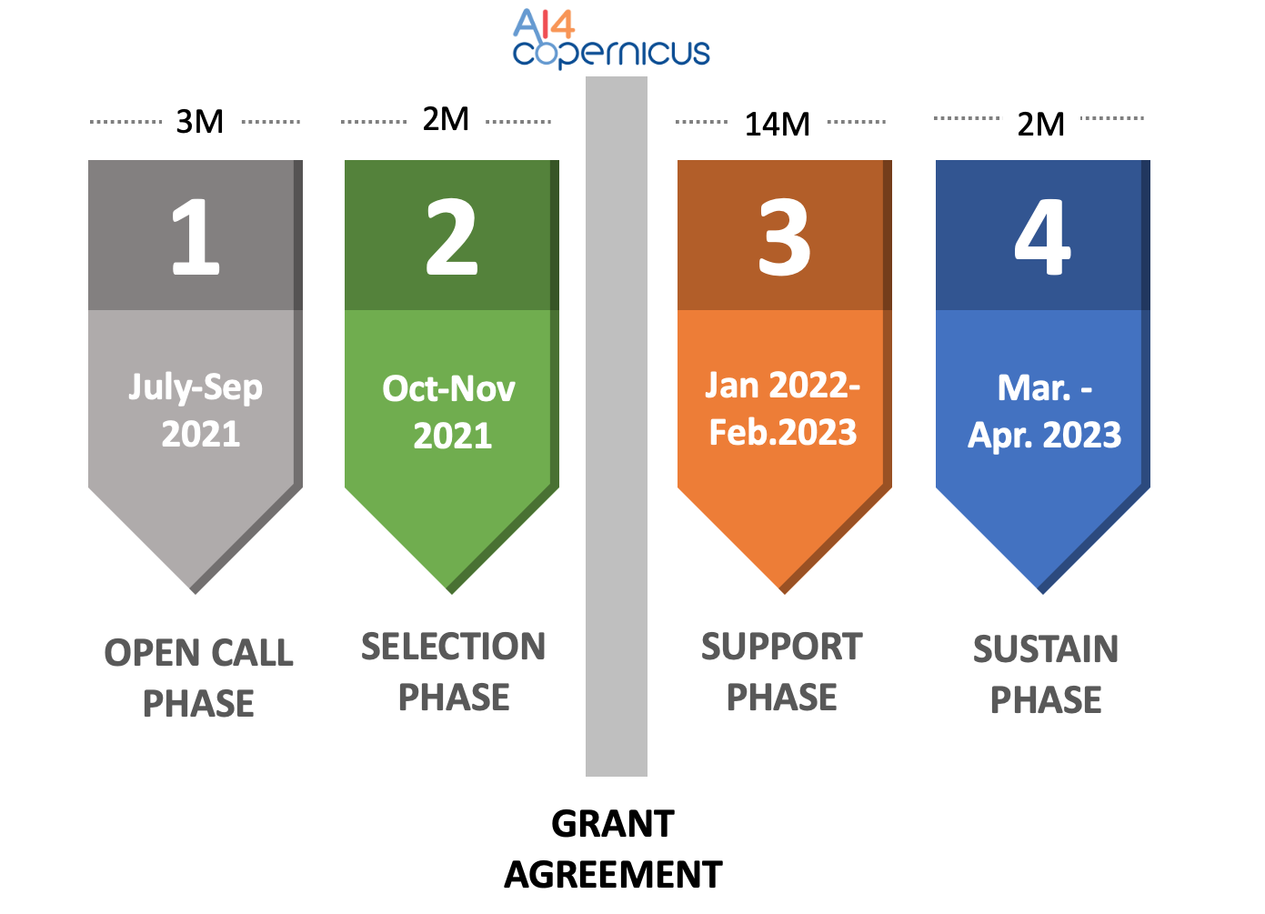
Figure 1: 1st Round of Open Call Phases for SMEs

During this period the following services, will be provided:
- Funding (depending to the type of the call) to implement their project for a period of 16 months
- AI4Copernicus Tools & Resources
- AI4EU, DIASes Tools & Resources
- Technical Mentoring
- Business & Sustainability Mentoring
- Certification: AI4Copernicus Trustmark
- Visibility through AI4Copernicus digital channels and events as AI4Copernicus Ambassadors

Can a project cover more than one industrial domain?
Yes, more than one industrial domain can be covered.

How long does it take to fill in the application?
The estimated time is 2-3 working days, once a specific project idea is formulated. Please, take into consideration that specific character limits have been established in each field of the online application form, so we encourage you to keep your proposal focused on the requested information, keeping in mind the AI4Copernicus concept and the requirements gathered in the Guide for Applicants for this call. We also recommend you start the submission process quite in advance before the deadline in order to avoid last minute circumstances.
If you have any questions feel free to let us know at info@ai4copernicus-project.eu

Do I have any conflict of interest?
Is your organisation directly linked with an AI4Copernicus Partner or a member of the Advisory Board?
If you answered NO then there is no conflict of interest and you can submit a proposal in the 1st Round of the AI4Copernicus Open Calls.

Will I be able to modify my proposal before final submission?
Multiple submissions are available until deadlines.

Will I be able to modify my proposal after the submission?
After the submission of your application, no modification is acceptable. Please, be aware that your application is completed before you proceed with its submission.

Can my organization submit more than 1 proposal in the same Call?
Yes, an organization is possible to submit more than 1 proposal as a partner, however, ONLY one as the coordinator.

I am an individual entrepreneur. Am I eligible for the single-company open calls (3rd Round of Open Call for experiments)?
Registered SMEs can participate in the following AI4Copernicus Open Calls: 1st Round, 3rd Round and 4th Round.
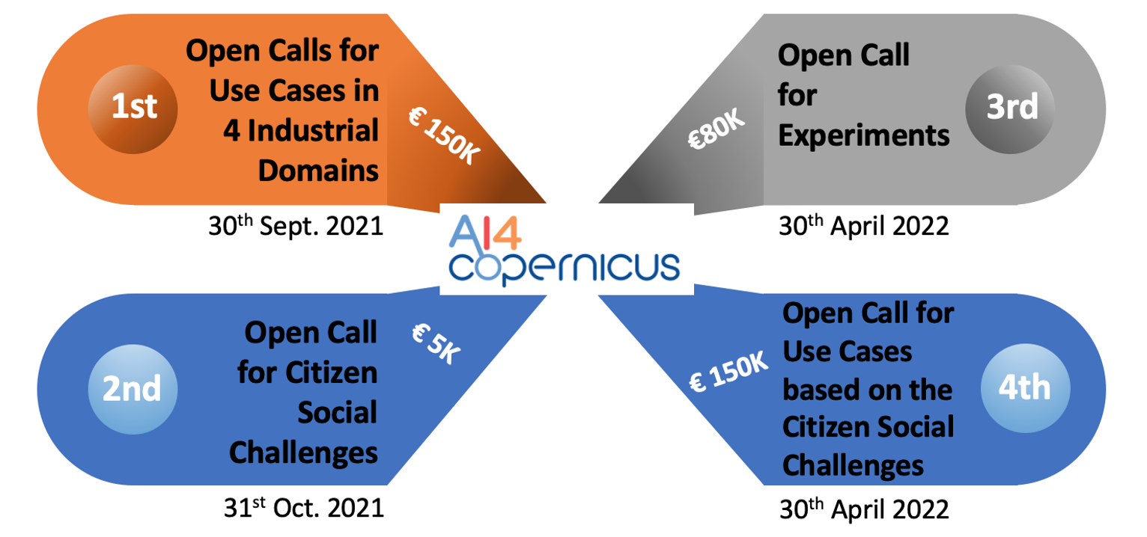
Figure 2: The 4 Rounds of the AI4Copernicus Open Calls (& submission deadlines)

I am an individual. Am I eligible for the AI4Copernicus open calls?
Individuals can participate in the AI4Copernicus Open Calls for citizens: 2nd Round (see figure 2).

What type of support is available for preparing the proposal?
The ‘Guidelines for Applicants’ is the main reference document. It provides detailed information about the requirements of the evaluation and selection process, and the Support Program offered by AI4Copernicus.
All the information needed will be provided to applicants via the following digital channels:
- Project’s website (more info): https://ai4copernicus-project.eu/
- Apply via: https://ai4copernicus-project.eu/open-call-info/
- AI4Copernicus Support team: info@ai4copernicus-project.eu

Do selected projects get any money in advance?
Yes, there will be an initial pre-financing (30% of the total funding) established at the beginning of the Support Program (M0).

What is the payment schedule and payment condition?
The maximum amount of financial support to be granted per selected project is up to €150.000 and beneficiaries will receive funding in the following installments:
- Award Stage (pre-financing): 30% of the total
- Interim Assessment: 30% of the total against depending of on the assessment out-come
- Proof of Concept Stage/Final Assessment: rest 40% of the total

Intellectual Property Rights (IPR) Issues: The IPR stays with whom?
The IPR will belong to the IPR holder(s) as it will be specified in the Project Proposal.
The AI4Copernicus will have NO claims over this IPR.

What will happen to the proposal related data?
If you have submitted a proposal, your project and company related information need to be stored on our servers until the payment of balance of the AI4Copernicus project, for potential reporting purposes towards the European Commission.
After this date all information will be deleted from our servers but will still be part of the statistics of the European Commission.

Is there any personal data processing?
AI4Copernicus requires certain types of your personal data, necessary in order to proceed with your application. These personal data types are: a) name, b) address (physical address and email), (c) telephone number. Your personal data will be kept strictly during the Open Call term, solely for the purposes of Open Call and will not be shared with any third party. For any inquiry regarding your personal data and your related rights you may contact info@ai4copernicus-project.eu.

Can I become part of the AI4Copernicus network and community?
Yes, you can join our community!
AI4Copernicus aims at developing a vibrant community of peers for knowledge exchange, networking and further collaboration processes in an open space format.
You can join us at: info@ai4copernicus-project.eu
In the event you opt to become part of this community you will be asked to fill in an online consent form.

When will the grant agreement be signed?
The “Funding and Support Services Agreement'' will be signed once the results of the 1st Round of AI4Copernicus Open Calls for Uses-Cases will be announced. Before signing the agreement between the consortia of selected projects, a Legal Check has to take place.

Do you have any additional questions that are not covered in this document?
If yes, please let us know: info@ai4copernicus-project.eu

SME Definition https://ec.europa.eu/growth/smes/sme-definition_en
Please note that, AI4Copernicus may withdraw an application in the event the participant is directly linked with an AI4Copernicus Partner or a member of the Advisory Board.

