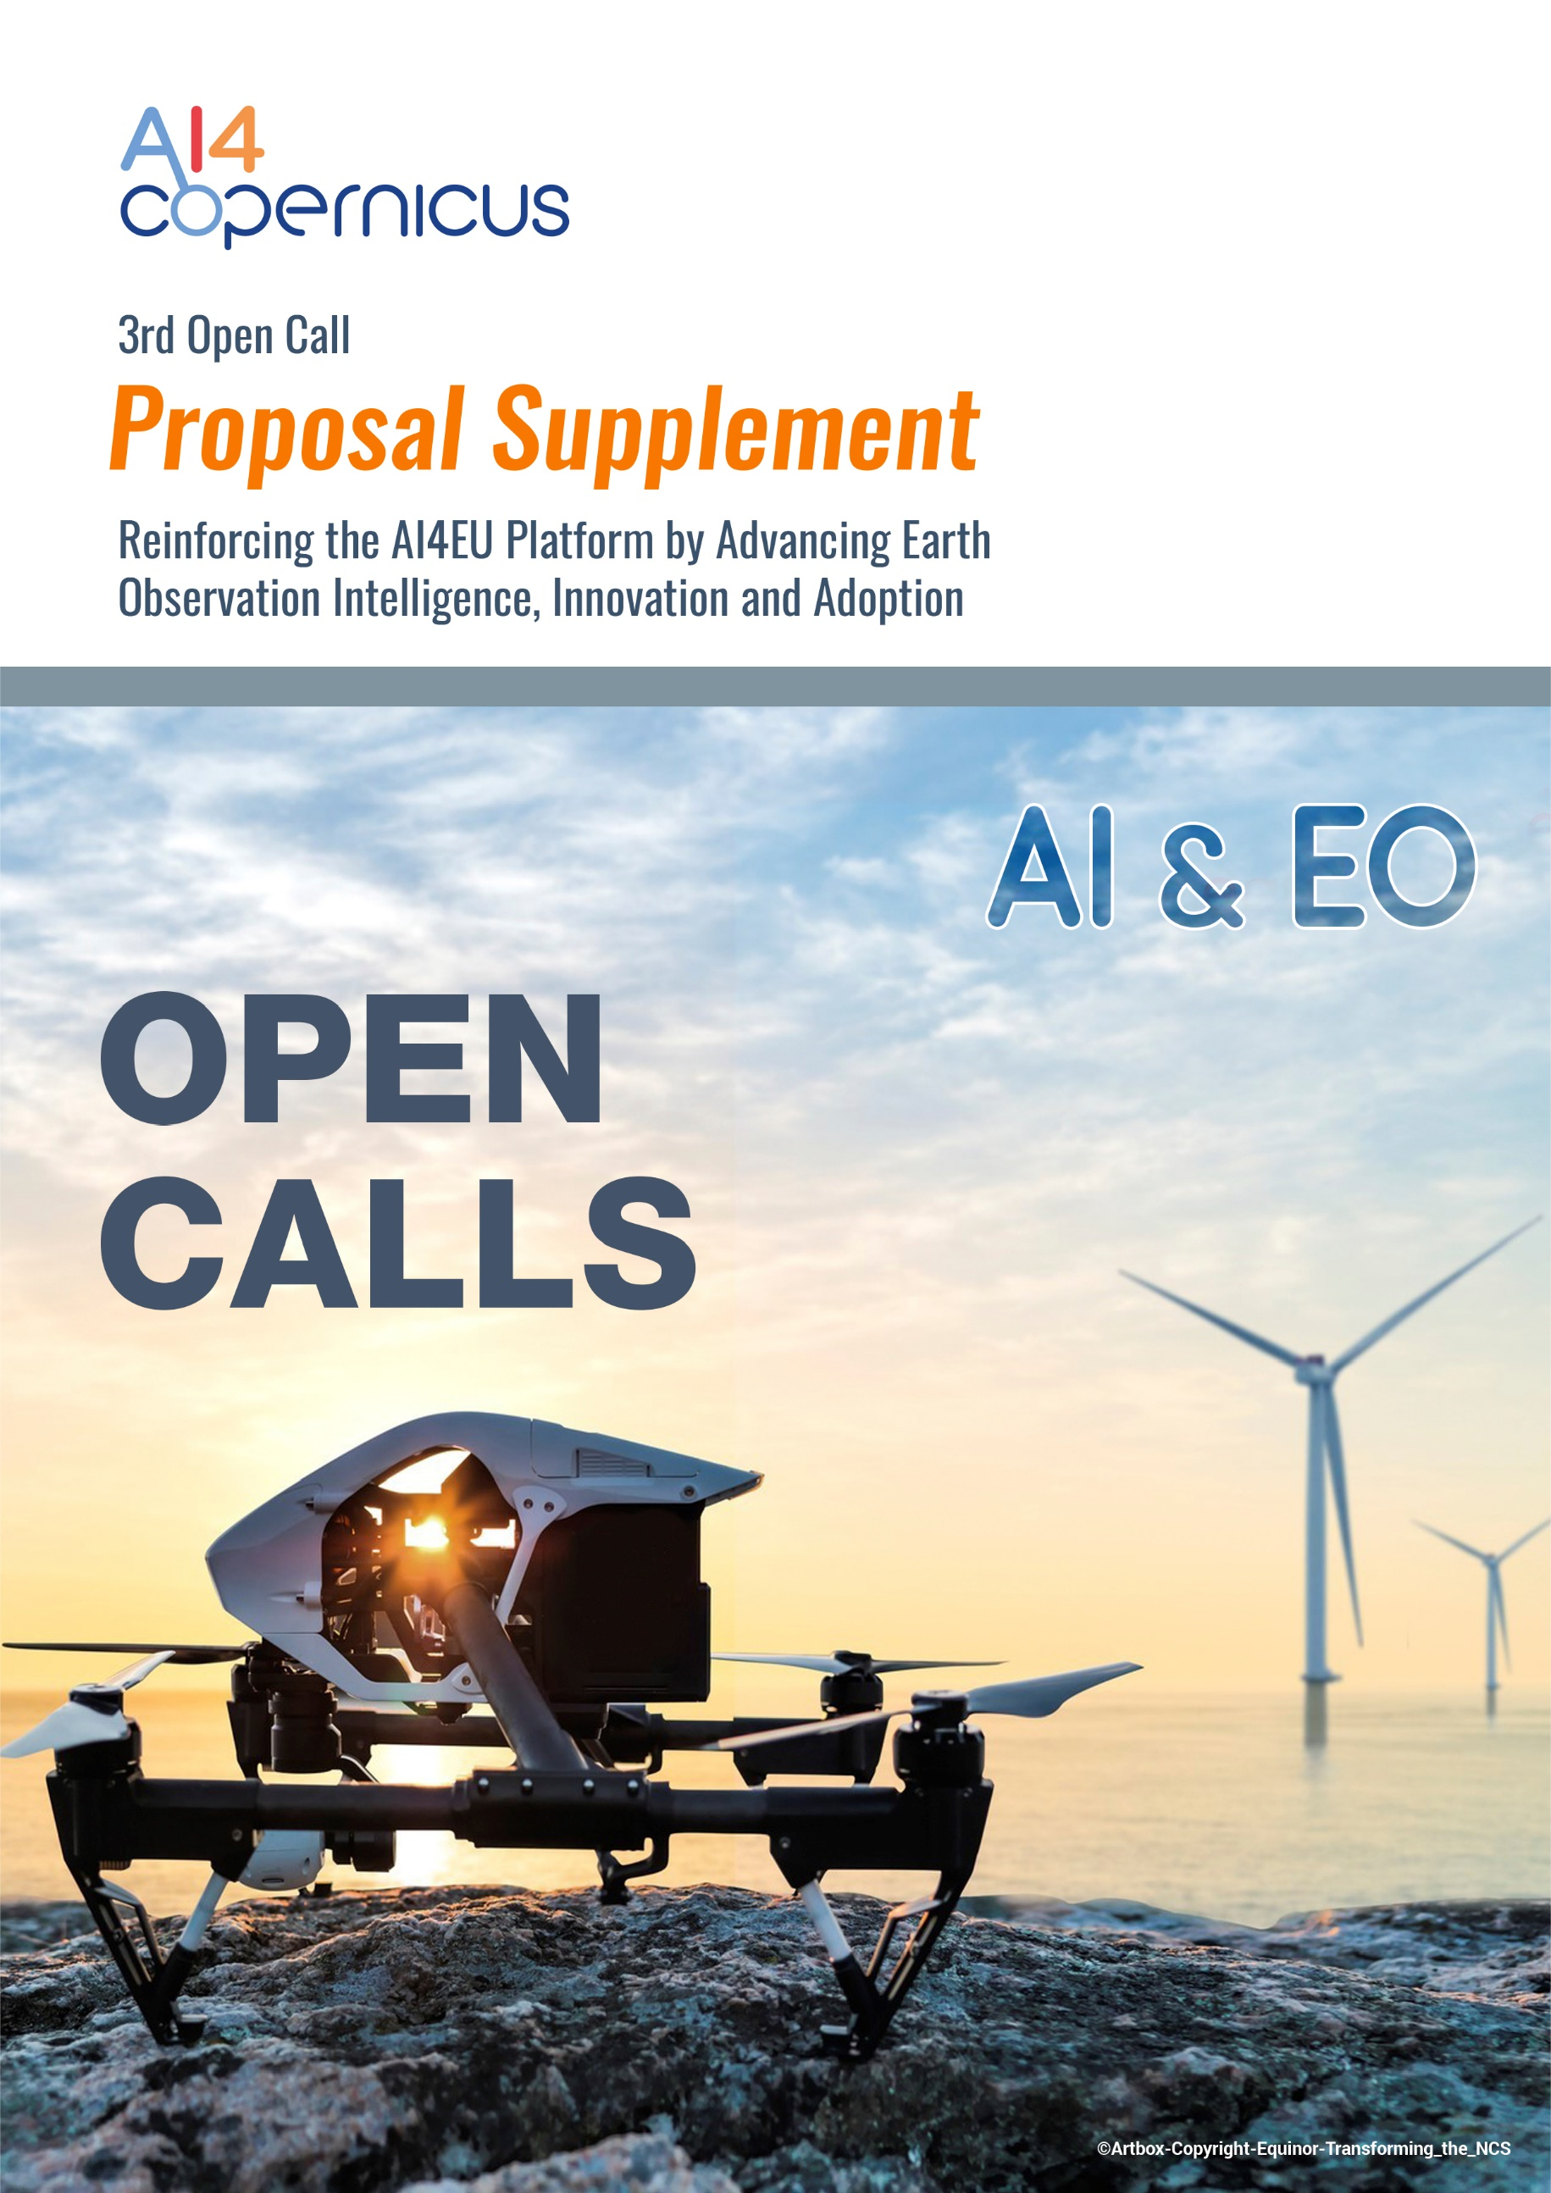

Table of Contents
Section 4: Company Details [up to 1 page] 4
Section 5: Ethical/Security Issues 4
5.1 Generic Ethical Issues 4
Ethics Self-Assessment 6
5.2 AI-related Ethical Issues 6
5.3 Security Issues 7

Notes:
- Page limit: Sections 4, should not be longer than 2 pages. The proposal supplement (Annex 3.1: Proposal Supplement) is not considered to be part of the 17-page limit of the Proposal template.
- Format: The reference font for the body text of proposals is Calibri (Windows platforms/Apple platforms). All tables must be included within this limit. The minimum font size allowed is 11 points. The page size is A4, and all margins (top, bottom, left, right) should be at least 15 mm (not including any footers or headers).
Please do not consider the page limit as a target! It is in your interest to keep your text as concise as possible, since experts rarely view unnecessarily long proposals in a positive light
Please eliminate this page when submitting the proposal

Section 4: Company Details [up to 1 page]
Company’s profile and previous experience to back up the appropriateness of the partner.

Section 5: Ethical/Security Issues

5.1 Generic Ethical Issues
 | YES/NO
Informed Consent
· Does the proposal involve children?
· Does the proposal involve patients or persons not able to give consent?
· Does the proposal involve adult healthy volunteers?
· Does the proposal involve Human Genetic Material?
· Does the proposal involve Human biological samples?
· Does the proposal involve Human data collection?
Research on Human embryo/foetus
· Does the proposal involve Human Embryos?
· Does the proposal involve Human Foetal Tissue / Cells?
· Does the proposal involve Human Embryonic Stem Cells?
Privacy
· Does the proposal involve processing of genetic information or personal data (e.g. health, sexual lifestyle, ethnicity, political opinion, religious or philosophical conviction)
· Does the proposal involve tracking the location or observation of people?
Research on Animals
· Does the proposal involve research on animals?
· Are those animals transgenic small laboratory animals?
· Are those animals transgenic farm animals?
· Are those animals cloned farm animals?
· Are those animals nonhuman primates?
Research Involving Developing Countries
· Use of local resources (genetic, animal, plant etc)
· Benefit to local community (capacity building i.e. access to healthcare,
education etc)
Dual Use
· Research having direct military application
· Research having the potential for terrorist abuse
ICT Implants
· Does the proposal involve clinical trials of ICT implants?
I CONFIRM THAT NONE OF THE ABOVE ISSUES APPLY TO MY PROPOSAL | YES/NO

NOTE: If you have entered any ethics issues in the ethical issue table, you must perform an ethics self-assessment.

Ethics Self-Assessment
If you have entered any issues in the ethics issue table, you must perform an ethics self-assessment in accordance with the guidelines
"How to Complete your Ethics Self-Assessment" and complete the table below.

Ethical dimension of the objectives, methodology and likely impact
Explain in detail the identified issues in relation to:
– objectives of the activities (e.g. study of vulnerable populations, etc.)
– methodology (e.g. clinical trials, involvement of children, protection of personal data, etc.)
– the potential impact of the activities (e.g. environmental damage, stigmatisation of particular social groups, political or financial adverse consequences, misuse, etc.)

Compliance with ethical principles and relevant legislations
Describe how the issue(s) identified in the ethics issues table above will be addressed in order to adhere to the ethical principles and what will be done to ensure that the activities are compliant with the EU/national legal and ethical requirements of the country or countries where the tasks are to be carried out. It is reminded that for activities performed in a non-EU countries, they should also be allowed in at least one EU Member State.

5.2 AI-related Ethical Issues
ARTIFICIAL INTELLIGENCE |  | Page
Does this activity involve the development, deployment and/or use of Artificial Intelligence?  If yes,  - detail in the self-assessment whether that could raise ethical concerns related to human rights and values and detail how this will be addressed  - Fillin the table below titled AI Ethical Assessment (Table 1) | Yes/ No

Table 1: AI Ethical Assessment
AI System |  | None | Low | Moderate | High | Very High | Don’t know | Detail your answer (& state the mitigation measures)
System Aim | Are there any ethical concerns related to human rights and values that could be raised by the aim/goal of the AI system that will be designed/developed/deployed in your project ?
Data | Are there any ethical concerns related to human rights and values that could be raised by the data that will be used in your project ?
Algorithm | Are there any ethical concerns related to human rights and values that could be raised by the algorithm(s) that will be designed/used in your project ?
AI Model | Are there any ethical concerns related to human rights and values that could be raised by the AI model that will be designed/used in your project ?
Output | Are there any ethical concerns related to human rights and values that could be raised by the output of your AI system in your project?

5.3 Security Issues
Please indicate if your project will involve:
Security Issues | YES/NO
'EU-classified information' (EUCI) as background or results
Activities or results raising security issues
Does this activity involve HE associated and/or third countries?
I CONFIRM THAT NONE OF THE ABOVE ISSUES APPLY TO MY PROPOSAL | YES/NO

