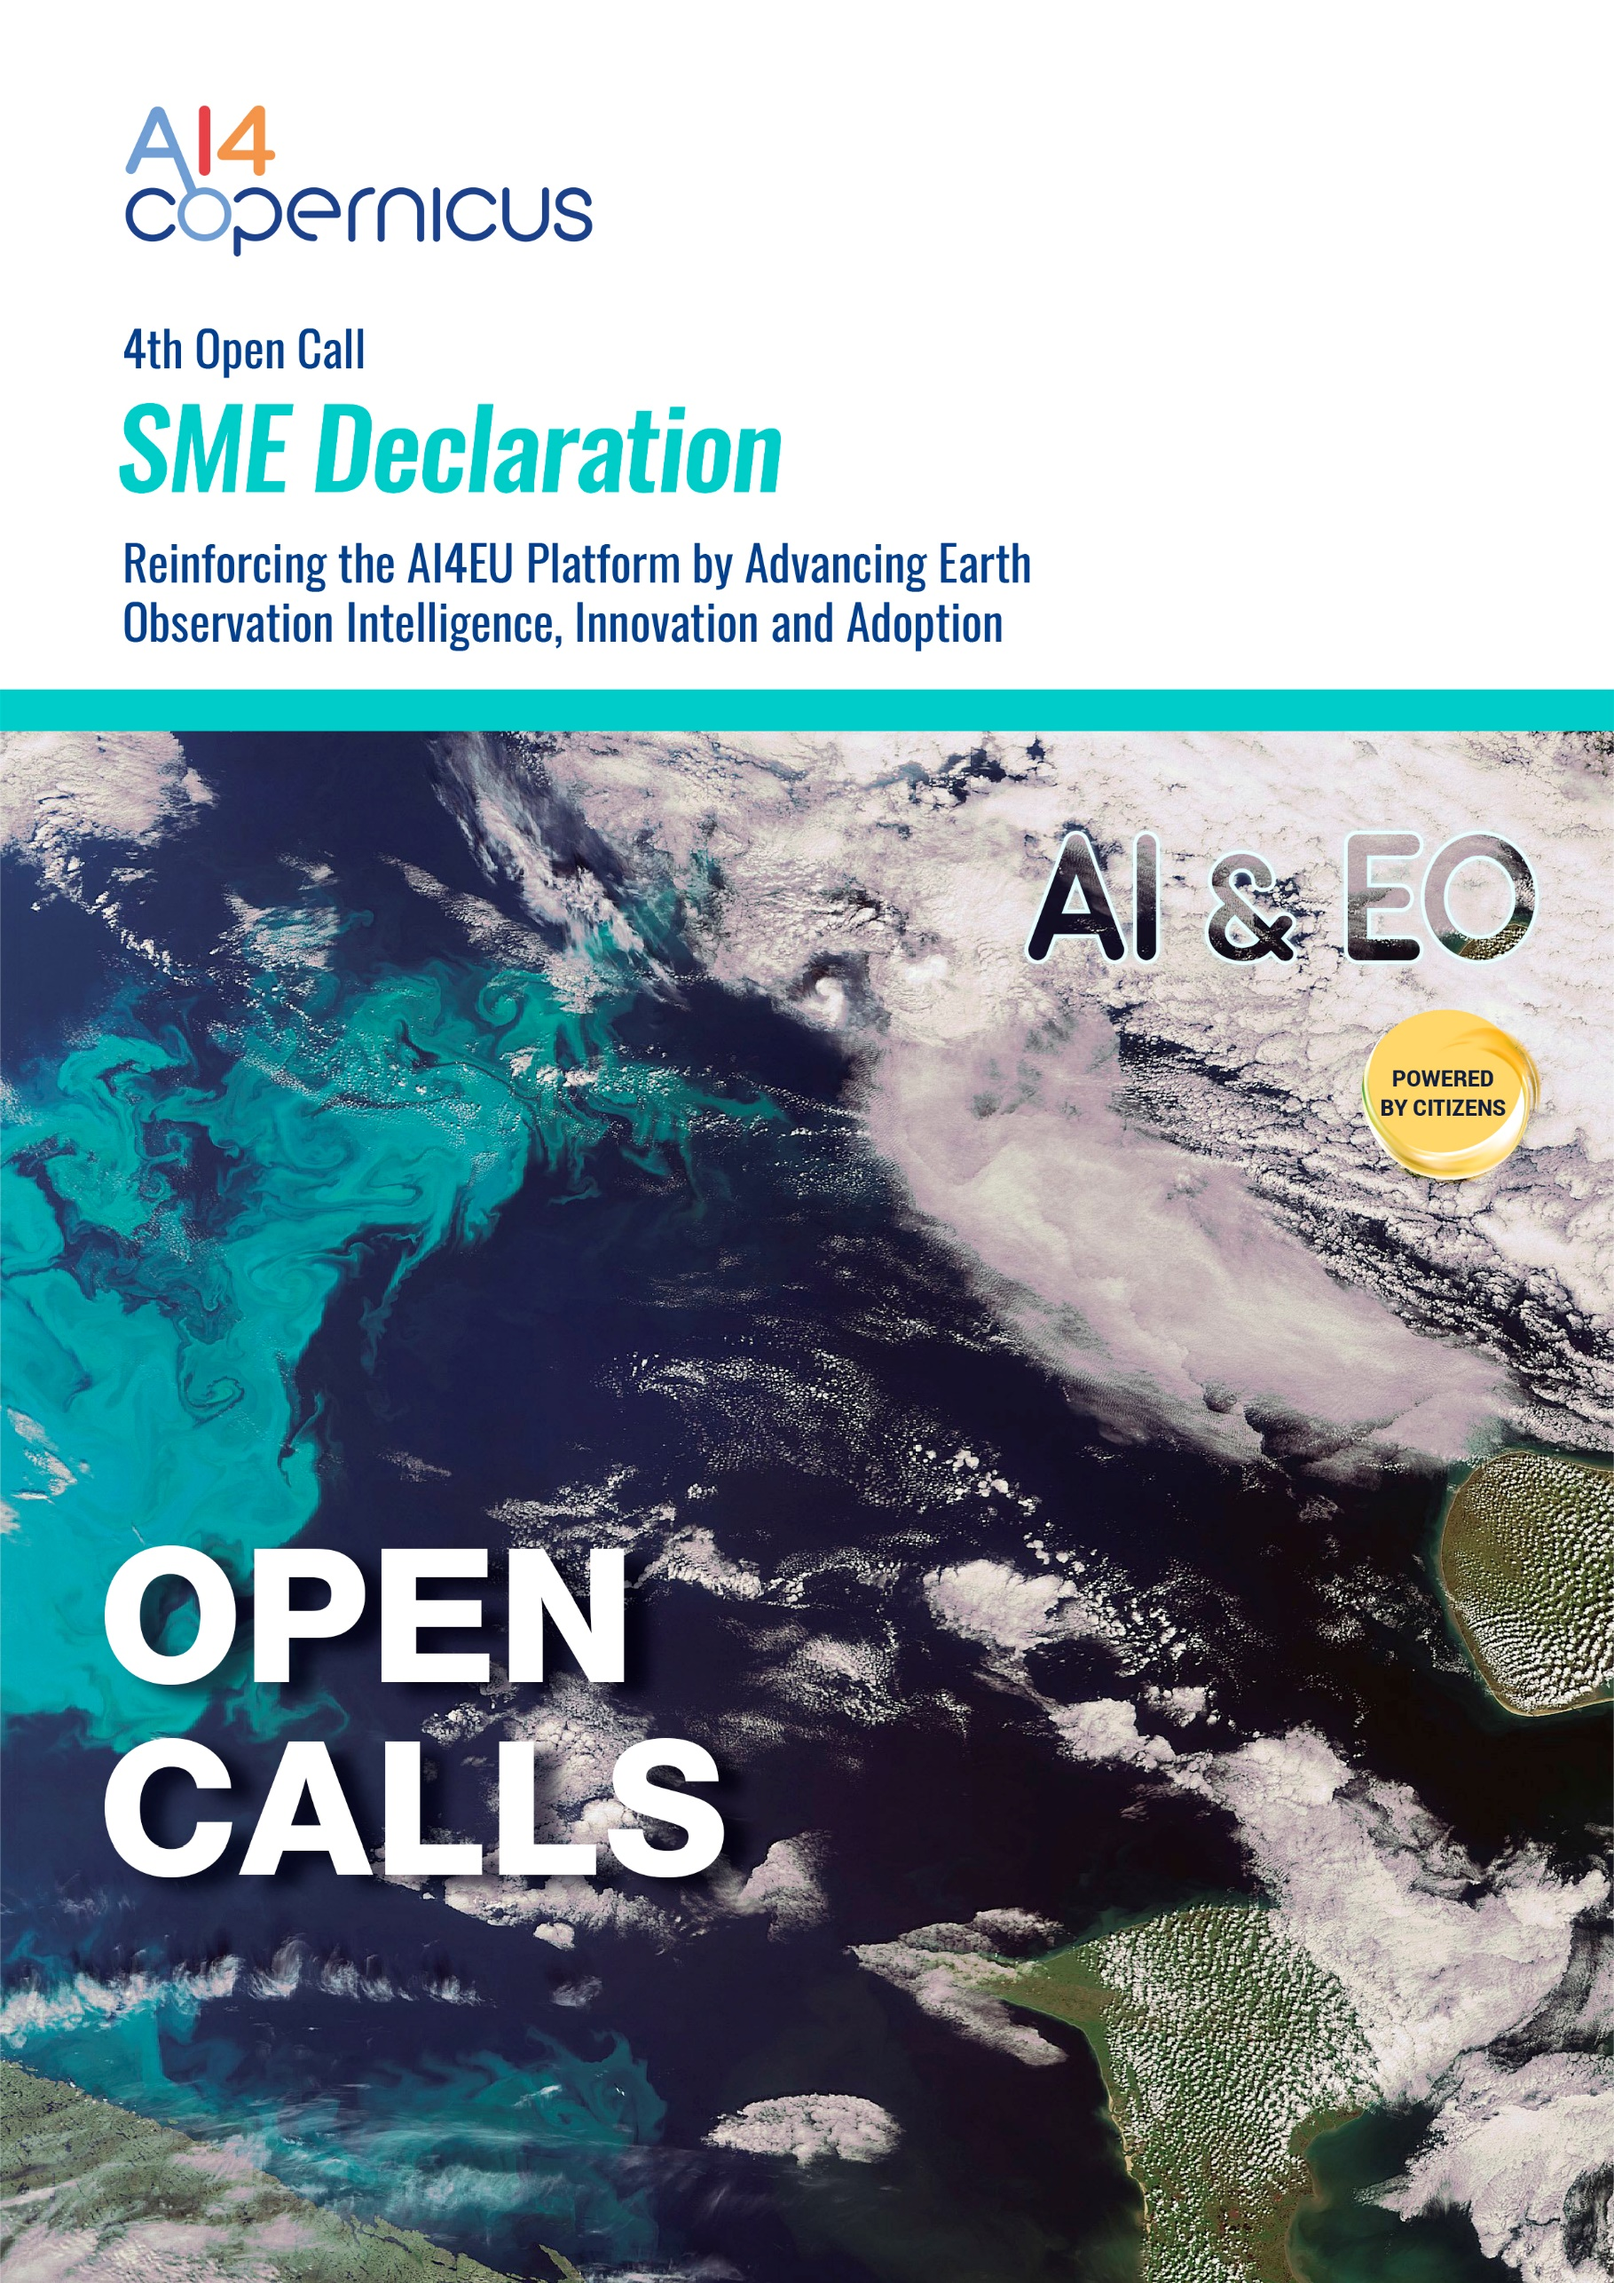
SME Declaration

Organization legal name
Is your organization engaged in (an) economic activit(y)ies?
(Yes or No)
If NO, you are not an (SM)Enterprise*. If YES, go to the next set of questions.
Last approved accounting period:
Your number of employees (in Annual Working Unit):
Your annual turnover (2020) (in €):
Your annual balance sheet total (2020) (in €):
The duration (in months) of your last approved accounting period:
The closing date (dd/mm/yyyy) of your last approved accounting period:
Note: Official exchange rate at the day of the closure of the accounting period (http://ec.europa.eu/budget/inforeuro)

If your number of employees is equal or superior to 250 persons (AWU) and your annual turnover is equal or exceeds EUR 50 million and/or your annual balance sheet total is equal or exceeds EUR 43 million, you are not an SME.

SIGNATURE and STAMP
(please provide a verified digital signature, if available; trusted providers can be found at https://esignature.ec.europa.eu/efda/tl-browser/#/screen/home).

Done at LOCATION, DD/MM/YYYY
NAME _SURNAME of the authorized Legal Representative
POSITION

