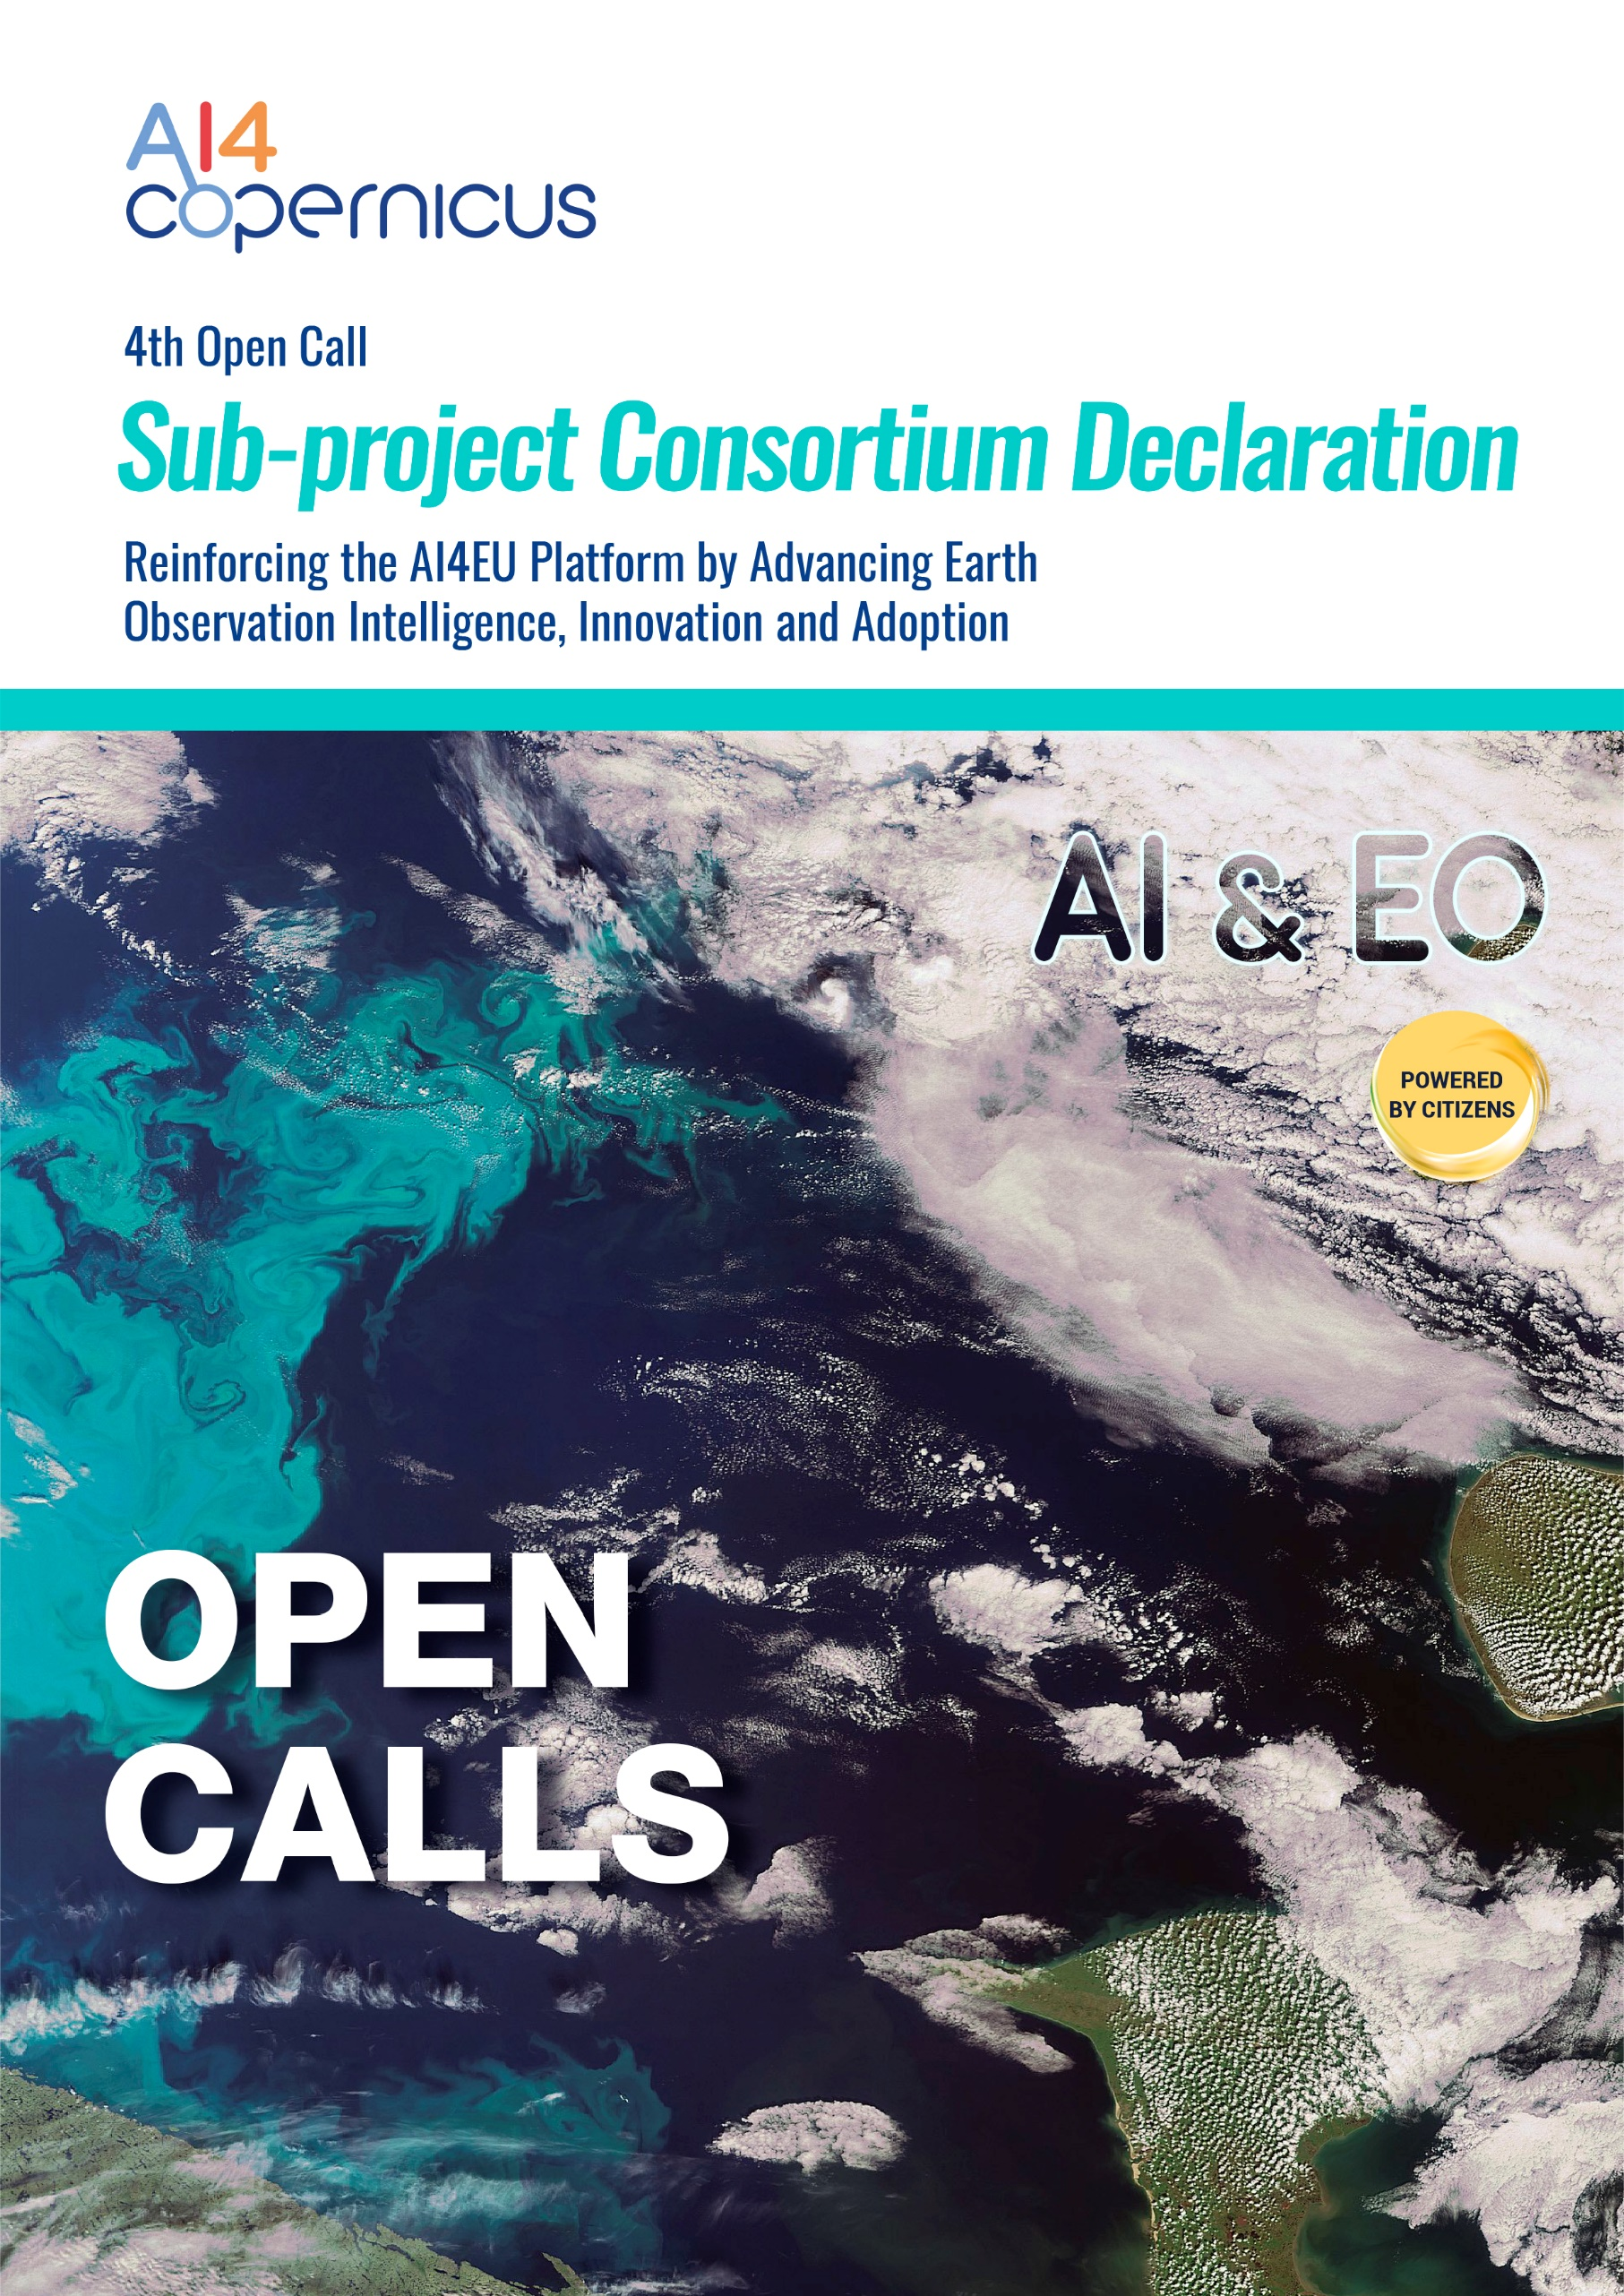

Sub-Project Declaration

Title of the Sub-Project: xxx
On behalf of the Sub-Project “xxx” (Name of the project), the xxxxx (Name of the Sub-project leader of the Consortium) as Sub-project Leader, established in ______________________________, (Official address), VAT/TAX number_________________, represented for the purposes of signing and submitting the Sub-Project Declaration by ___________________________ (Name of legal representative), declares that:
- All provided information provided for Sub-Project: ___________ (Name of the project) is true, complete and legally binding
- All Sub-Project Selected Third Parties represented and signing herein, have agreed on their roles and budget shares
- All Sub-Project Selected Third Parties represented and signing herein comply, for the entire duration of the action, with the eligibility criteria set out in the specific call for proposals and have the required financial and operational capacity as set out in the 4rth AI4Copernicus Open Call for Use Cases based on citizen social challenges
- ________________ (Sub-Project Leader) is committed to act as the Sub-Project Leader for this action
- AI4Copernicus Consortium bears no responsibility in case the Sub-Project Leader violates the mutual agreement set in this Sub-Project Declaration
- ΑΙ4Copernicus Consortium bears no responsibility in case of dispute among Sub-Project Selected Third Parties regarding IP rights
- To the extent that performance of the Sub-Project Selected Third Parties under the Sub-Project _______________________ (Sub-project Title) requires the processing of personal data as defined in the GDPR, ΑΙ4Copernicus Consortium bears no responsibility in case of any losses, liabilities, damages, costs, charges, claims cost of breach notification including notifications to the data subject, cost of complaints handling (including providing data subjects with credit reference checks, setting up contact centers (e.g. call centers) and making ex gratia payments), all whether arising in contract, tort (including negligence), breach of statutory duty or otherwise imposed.
By signing this Sub-Project Declaration, the Sub-Project leader declares that it is not coordinating any other competitive Sub-Project in the context of AI4Coperinicus 4th Open Call. In case, the Sub-Project leader of the Consortium coordinates more than one Consortia, all associated proposals will be automatically excluded from the evaluation process.

Done at LOCATION, DD/MM/YYYY

NAME _ SURNAME

POSITION

SIGNATURE for the Sub-Project leader
(please provide a verified digital signature, if available; trusted providers can be found at https://esignature.ec.europa.eu/efda/tl-browser/#/screen/home).

Type of Beneficiary: - Open Calls for Use-Cases in any industrial domain based on the citizen-driven social themes/challenges (4th Round of Open Calls for Use-Cases): Consortia of SMEs including at least 1 non-or low-tech SME by default (EU member state or Associated Countries)

