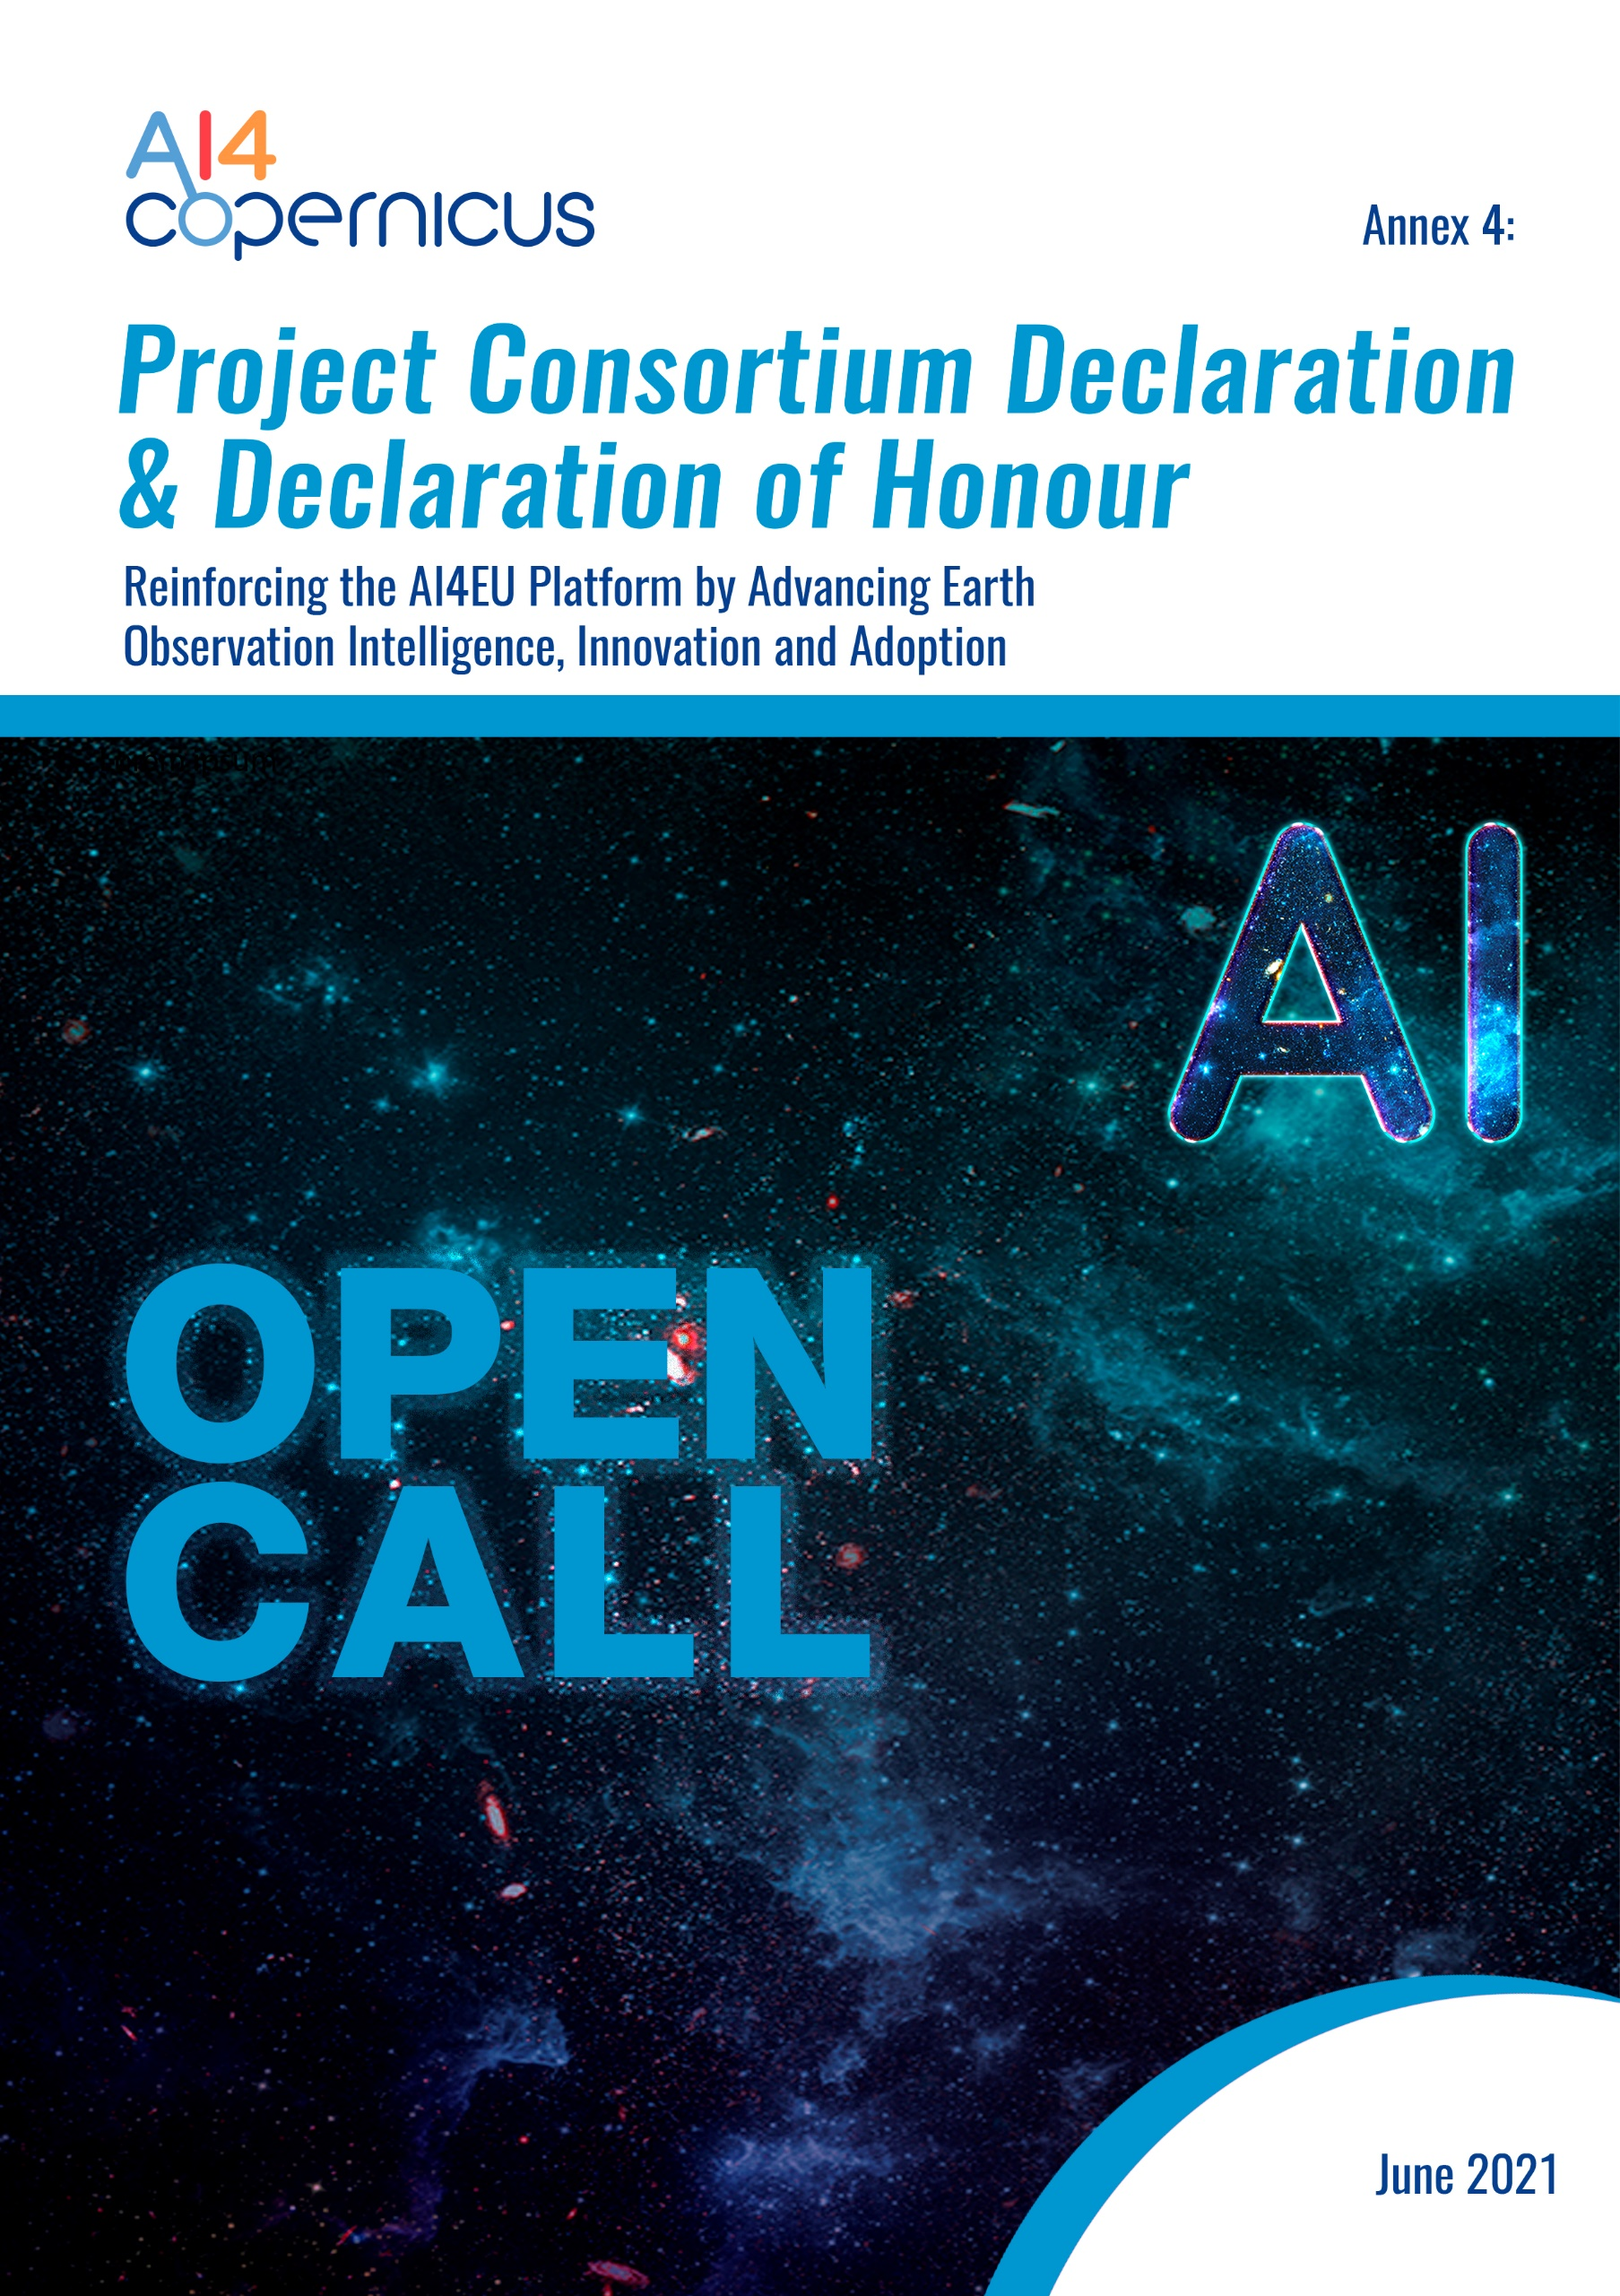

Sub-Project Declaration
Title of the Sub-Project: VALENS
On behalf of the Sub-Project “xxx” (Name of the project), the xxxxx (Name of the Sub-project leader of the Consortium) as Sub-project Leader, established in ______________________________, (Official address), VAT/TAX number_________________, represented for the purposes of signing and submitting the Sub-Project Declaration by ___________________________ (Name of legal representative), declares that:
- All provided information provided for Sub-Project: xxxx (Name of the project) is true, complete and legally binding
- All Sub-Project Selected Third Parties represented and signing herein, have agreed on their roles and budget shares
- All Sub-Project Selected Third Parties represented and signing herein comply, for the entire duration of the action, with the eligibility criteria set out in the specific call for proposals and have the required financial and operational capacity as set out in the “AI4Copernicus 1st Open Call for Use-cases in the domains of Health, Energy, Security, Agriculture’’
- Xxxx (Name of the project) is committed to act as the Sub-project Leader for this action
- AI4Copernicus Consortium bears no responsibility in case the Sub-Project leader violates the mutual agreement set in this Sub-Project Declaration
- ΑΙ4Copernicus Consortium bears no responsibility in case of dispute among Sub-Project Selected Third parties regarding IP rights
- To the extent that performance of the Sub-Project Selected Third parties under the Sub-Project leader xxxx (Name of the project) requires the processing of personal data as defined in the GDPR, ΑΙ4Copernicus Consortium bears no responsibility in case of any losses, liabilities, damages, costs, charges, claims cost of breach notification including notifications to the data subject, cost of complaints handling (including providing data subjects with credit reference checks, setting up contact centres (e.g. call centres) and making ex gratia payments), all whether arising in contract, tort (including negligence), breach of statutory duty or otherwise imposed.
By signing this Sub-Project Declaration, the Sub-Project leader declares that it is not coordinating any other competitive Sub-Project in the context of AI4Coperinicus 1st Open Call. In case, the sub-project leader of the consortium coordinates more than one Consortia, all associated proposals will be automatically excluded from the evaluation process.

Done at LOCATION, DD/MM/YYYY

NAME_SURNAME

POSITION

SIGNATURE for the Sub-Project leader

Selected Third Parties Declaration of Honour on exclusion criteria and absence of conflict of interest

All Selected Third Parties signing this declaration of Honour declare that all provided information below is true and legally binding:

Each undersigned Selected Third Party:

1. Declares that is not in one of the following situations:
- bankrupt or being wound up, is having its affairs administered by the courts, has entered into an arrangement with creditors, has suspended business activities, is the subject of proceedings concerning those matters, or is in any analogous situation arising from a similar procedure provided for in national legislation or regulations;
- it or persons having powers of representation, decision making or control over it have been convicted of an offence concerning their professional conduct by a judgment which has the force of res judicata;
- guilty of grave professional misconduct proven by any means which the contracting authority can justify including by decisions of the European Investment Bank and international organizations;
- in breach with its obligations relating to the payment of social security contributions or the payment of taxes in accordance with the legal provisions of the country in which it is established or with those of the country of the contracting authority or those of the country where the contract is to be performed;
- it or persons having powers of representation, decision making or control over it have been the subject of a judgment which has the force of res judicata for fraud, corruption, involvement in a criminal organization or any other illegal activity, where such illegal activity is detrimental to the Union’s financial interests;
- subject to an administrative penalty for being guilty of misrepresenting the information required by the contracting authority as a condition of participation in a grant award procedure or another procurement procedure or failing to supply this information or having been declared to be in serious breach of its obligations under contracts or grants covered by the Union's budget;
2. Declares that:
- is not subject to a conflict of interest;
- has not made false declarations in supplying the information required by the as a condition of participation in the Open Calls of AI4Copernicus Project or does not fail to supply this information;
- is not in one of the situations of exclusion, referred to in the above-mentioned points a) to f);
- is aware and fully accepts all AI4Copernicus condition and rules as expressed in AI4Copernicus open call documents Annex 1, Annex 2, Annex 3 and Annex 4;
3. Certifies that:
- is committed to participate in the above-mentioned Sub-Project;
- has stable and sufficient sources of funding to maintain its activity throughout its participation in the above-mentioned Sub-Project and to provide any counterpart funding necessary;
- has or will have the necessary resources as and when needed to carry out its involvement in the above-mentioned Sub-Project;
- is committed to comply with the highest standards of ethical principles and research integrity and confirm that the work is free of plagiarism;

For xxxxx as Sub-project leader

Done at LOCATION, DD/MM/YYYY

NAME_SURNAME

POSITION

SIGNATURE of the Legal Representative

For xxxx as Selected Third Party

Done at LOCATION, DD/MM/YYYY

NAME_SURNAME

POSITION

SIGNATURE of the Legal Representative

For xxxxx as Selected Third Party

Done at LOCATION, DD/MM/YYYY

NAME_SURNAME

POSITION

SIGNATURE of the Legal Representative

Type of Beneficiary: Open Calls for Use-Cases in the domains of Health, Energy, Security, Agriculture (1st Round of Open Calls for Use-Cases): Consortia of SMEs including at least 1 non-or low-tech SME by default

