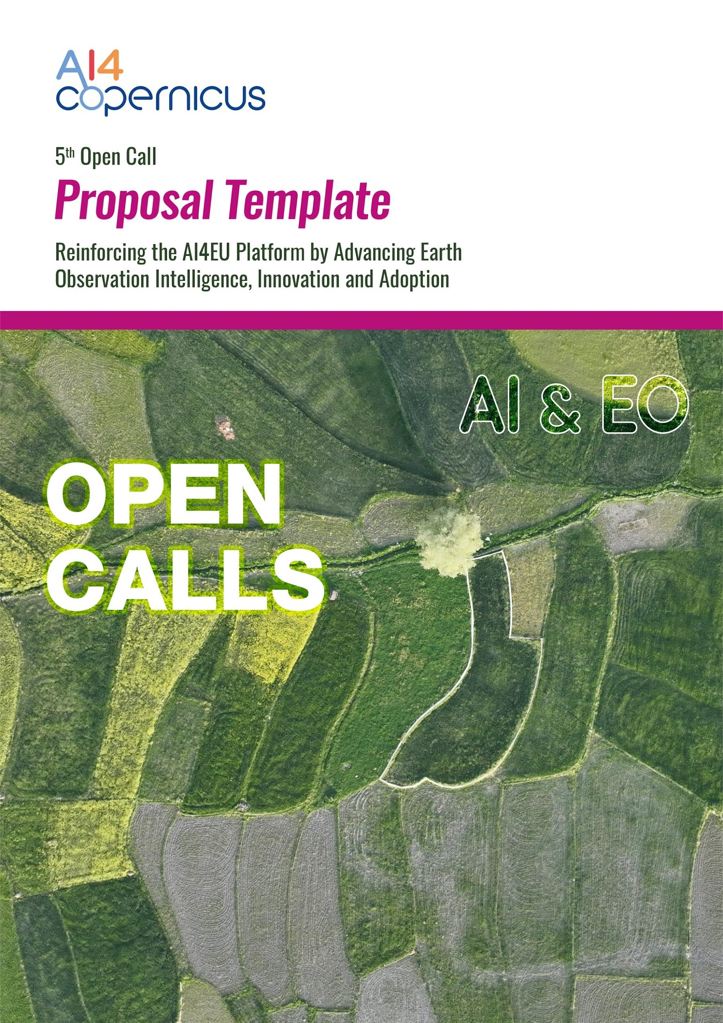

Table of Contents
Section 1. Objectives and Methodology [up to 3 pages] 4
1.1 Testing objectives [up to ½ page] 4
1.2 Innovation of the existing services [up to ½ page] 4
1.3 Testing Methodology [up to 2 pages] 4
1.3.1 AI4Copernicus, AI4EU, DIASes Service Utilisation 4
Section 2. Testing Implementation [up to 5 pages] 5
2.1 Workplan [up to 3 pages] 5
2.1.1 Gantt Chart 5
2.1.2 Description of Tasks 5
2.2. Company profile [up to 1 page] 6
2.2.1 Company description 6
2.2.2 Gender-responsive approach 7
2.3. Budget Breakdown [up to 1 page] 7

Notes:
- Template Structure: The structure of this template must be followed when preparing your proposal. It has been designed to ensure that the important aspects of your planned work are presented in a way that will enable the experts to make an effective assessment against the evaluation criteria. Sections 1 and 2 each correspond to the AI4Copernicus evaluation criteria.
- Evaluation: Please be aware that proposals will be evaluated as they were submitted, rather than on their potential, if certain changes were to be made. This means that only proposals that successfully address all the required aspects will have a chance of being funded.
- Page limit: Sections 1 & 2, together, should not be longer than 8 pages (Annex 3: Proposal Template). All tables, figures, references and any other element pertaining to these sections must be included as an integral part of these sections and are thus counted against this page limit. The page limit of 8 pages will be applied; therefore, you must remove this instruction page (as well as all other highlighted instructions within the template) before submitting. Please note that if your proposal exceeds the page limit of 8 pages (Section 1 & 2) then after page 8 the content will not be considered during evaluation. The proposal supplement (Annex 3.1: Proposal Supplement) is not considered to be part of this 8-page limit.
- Format: The reference font for the body text of proposals is Calibri (Windows platforms/Apple platforms). All tables must be included within this limit. The minimum font size allowed is 11 points. The page size is A4, and all margins (top, bottom, left, right) should be at least 15 mm (not including any footers or headers).
Please do not consider the page limit as a target! It is in your interest to keep your text as concise as possible, since experts rarely view unnecessarily long proposals in a positive light
Please eliminate this page when submitting the proposal

Section 1. Objectives and Methodology [up to 3 pages]

1.1 Testing objectives [up to ½ page]
Please describe briefly the objectives of your proposed work relevant to testing AI4Copernicus services. Describe your existing services from a technical and business perspective, how they relate to the utilised AI4Copernicus services.

1.2 Innovation of the existing services [up to ½ page]
Provide information regarding the level of innovation of your existing services within your market and how it will exceed the state of the art by utilising the AI4Copernicus services.

1.3 Testing Methodology [up to 2 pages]
Please describe and explain your testing methodology, including the concepts, models, architecture and assumptions fitted on your company profile. Explain how this will enable you to deliver your project’s testing objectives; that is how it will contribute to the overall boosting of your company services and products and company workflow.
For example, you can provide a detailed example case listing the AI4Copernicus services which you plan to utilise, needed data, tools, resources and the expected testing decision outcome.

1.3.1 AI4Copernicus, AI4EU, DIASes Service Utilisation
Data and processing prerequisites:  (e.g., Sentinel-5 data, Sentinel-2 data, etc) | The project should make use of Copernicus data.
Usage of AI4Copernicus Services:  (e.g., Sentinel-1 GRD pre-processing, Deep network for pixel-level classification of S2 patches, etc) | Please list the services that you will use (by referring to the relevant section in the AI4Copernicus Technical documentation) and how each service will be used in your project. Proposals that won’t make use of AI4Copernicus services will not be evaluated.
Usage of AI4EU Services:  (e.g., Semantic Web toolkit, I-NERGY services etc) | Additional supplementary services can be found here and here.
Usage of DIASes Services:  (CREODIAS or WEKEO) | Please note that either CREODIAS or WEKEO should be used.
External Resources: | Please state whether you are expecting to generate new datasets during the execution of your project.

Section 2. Testing Implementation [up to 5 pages]

2.1 Workplan [up to 3 pages]
Please provide a detailed description of the work plan that you will follow in order to reach your testing objectives. Describe the individual tasks for your technology development taking to account that your project will involve a 5-months Testing Phase:

2.1.1 Gantt Chart
We suggest organising your testing workplan using up to 2-3 tasks. However, if you want optionally to use more tasks in your workplan feel free to do so.
Activities | M1 | M2 | M3 | M4 | M5*
Task 1.1 [Name] |  | ♦
Task 1.2 [Name]
* Final Assessment
♦ Deliverable

2.1.2 Description of Tasks
Please provide the details for each task which provides an overview of the work.
Please remember to include deliverables (DX.X) by default:
- DX.1: Interim report: A progress report of the testing activities during the first period of the project. [M2]
- DX.2: Final report: A final report of the testing activities during the second period of the project [M4]
- DX.3: Video Pitch: Video of 5 to 7 minutes showing and explaining in detail the challenge, the idea, the key features and characteristics of the solution. [M5]
- DX.4: Publishable summary with figure: A short-written text about the project (200-300 words) in a form of publishable case-study. [M5]
If you want optionally to include further deliverables in your workplan feel free to do so.

Task 1.1: [name and timing information, start month to End month]
Person-months
Objectives:
- …
- ….

Description of work:

List of Deliverables:
Please define the deliverables and denote the delivery month, responsible partner and the type of the deliverable.
e.g., D.1.1.x Name of the deliverable [MX, Partner X] [Type of Deliverable]

List of Milestones:
M1.x Name of Milestone [Mx]
(Please add tables for each task that you want to describe)

List of Tasks & Effort
Tasks No. | Task Names | Duration  (Mx-My) | Effort
T1.1 | Name
Total

2.2. Company profile [up to 1 page]
Please provide a short description of the organisation, the main tasks attributed to it, and its previous experience relevant to those tasks.
Provide a short profile of the staff members (in the sections that follow) who will undertake the work and their commitment expressed as a percentage of the full-time equivalent.
Applicants are encouraged to endorse a gender-responsive approach regarding the selection of staff members.

2.2.1 Company description
Please provide a short description of the organisation

Name
Description
1-2 Key Persons
Contact Person
Relevant projects/activities
Relevant publications/ products/ services/ achievements
Existing infrastructure/ technical equipment relevant to the project
Involvement in another proposal applied to AI4Copernicus Open Calls (Y/N)

Please note that in the Section 4 “Company Details” of Annex 3.1: Proposal Supplement, you are able to provide additional information.

2.2.2 Gender-responsive approach
Identify your approach regarding gender-responsive approach for the selection of staff members.

2.3. Budget Breakdown [up to 1 page]
Please detail the budget that you need, describe the travel expenses and other major cost items. Include costs for travel, including to joint events such as workshops, and for dissemination and exploitation events during the runtime of the project, for the creation of reports, demonstrations, etc.
Example
The project partner is committed to mobilise the resources needed to guarantee the achievement of the results. The total budget is of xxx.xxx,xx €. The total requested funding is of xxx.xxx,xx €.
Breakdown of costs (please, provide the costs for Part I and Part II):
- Personnel Cost: the involvement of the x participants in the xx months will amount to xxx.xxx,xx €
- Travel cost: attendance to technical meetings will amount to xxx.xxx,xx €
- Indirect costs: the indirect costs will amount to xxx.xxx,xx € [25% of total direct costs (i) + (ii) + (iii)]

Budget and cost justification Table
Categories | Budget
Personnel Cost
Travel Cost
Indirect Cost
Total Cost

(Please note that the 5th Open Call addressed to single partner micro-projects of high-tech SMEs)

Justifications
Please provide any justifications if and where needed.

